Anglo-Saxon and Norman England, 1066-88
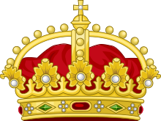
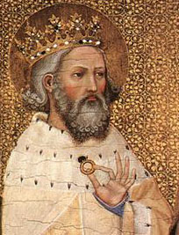
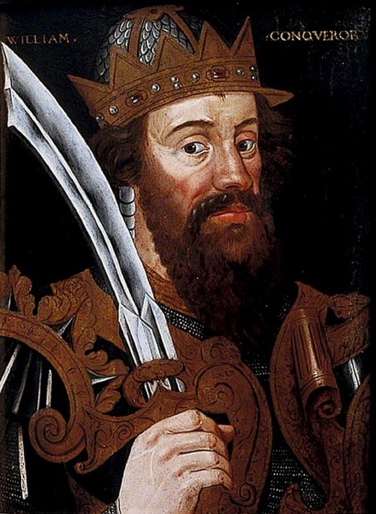

A brief overview of key people, dates and facts about England from 1060-88
Please note- events discussed in the booklet are not detailed enough to be studied without using your class notes. This is meant more as a resource you can use to check your knowledge of dates and people and use as an aid to your understanding.
Key topic 1: Anglo-Saxon England and the Norman Conquest, 1060-1080
Key area | Content | Revised
Anglo- Saxon Society | - Monarchy and government. The power of the English monarchy. Earldoms, local governments and the legal system.  - The economy and social system. Towns and villages. The influence of the Church
The last years of Edward the Confessor and the succession crisis | - The house of Godwin. Harold Godwinson’s succession as Earl of Wessex. The power of the Godwins.  - Harold Godwinson’s embassy to Normandy. The rising against Tostig and his exile. The death of Edward the Confessor.
The rival claims to the throne | - The motives and claims of William of Normandy, Harald Hardrada and Edgar.  - The Witan and the coronation and reign of Harold Godwinson.  - Reasons for, and significance of, the outcome of the battles of Gate Fulford and Stamford Bridge.
The Norman Invasion | - The Battle of Hastings  - Reasons for William’s victory, including the leadership skills of Harold and William, Norman and English troops and tactics.

13 Key things to know about Anglo-Saxon society
- Anglo- Saxon means people who settled in England after the Romans left Britain. They come from Germany, Belgium and the Netherlands.
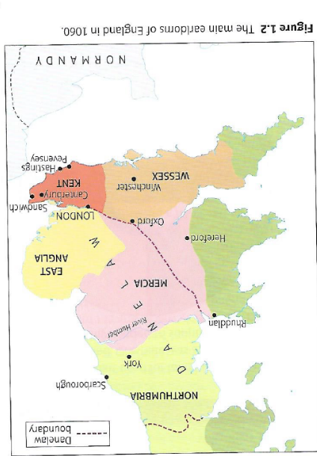
- Scotland and Wales were independent and the King did not control these areas.
- England was separated into Earldoms- these were separate areas of Britain each controlled by an earl. They included: Northumbria, Mercia, East Anglia, Kent and Wessex.
- Earldoms were divided into shires. These had many different functions, such as having their own courts and fortified towns known as Burhs as well as providing men to fight in case of invasion.
- England faced constant invasion threats from Vikings in Scandinavia and had in fact been invaded before Edward the Confessor became King in 1042.
- The population of England was relatively small compared to today, it is estimated that there were around 2 million people living in England.
- England was by no means united. Often people were loyal only to their region and not to England. In the North, many people lived under Danelaw- where Viking power had been strongest and where Danish law had been kept rather than Anglo-Saxon law.
- Farming was the biggest industry in Anglo-Saxon England. Society was split between peasants, Slaves, Thegns and Earls.
  - Peasants- rented small amounts of land from the local lord (Thegn) and did work for the lord as well as farming food to feed their family. If they did not do what the lord wanted they could lose their land. There were Ceorls, who were free to work for another lord if they wished.
  - Slaves- 10% of Anglo-Saxon population were slaves. They could be bought or sold and were seen as people’s property.
  - Thegns- local lords. There were between 4,000 and 5,000 Thegns by 1060. They held more land than peasants and peasants were answerable to the Thegns.
  - Earls were the most important men in the country after the King. Controlled the Earldoms.
- Although most of the population lived in the countryside- 10% of people lived in towns. Trade was common and towns often traded internationally. York traded with Denmark and London traded with lots of different European countries including Germany and France.
- The Earls and other important bishops and archbishops advised the King on issues of government and they became known as the Witan. They had a key role in approving a new King. Religion was especially important in Anglo-Saxon England and bishops would be asked to give opinions on the Kings ideas. Most member of the church were educated and so could read and write about what was happening.
- The Church was very important in everyday life. Everybody was religious and believed in heaven and hell.
- Kings believed that they were granted their power by God and it was only God that could take this power away.
- The King gained his legitimacy through many areas, however, a key leadership quality that made Kings legitimate was their ability to be good soldiers and win battles.

Key Terms for Anglo Saxon Society
Anglo Saxon | People who settled in Britain after the Romans. They came from what is now Germany, Belgium and the Netherlands
Anointed | To put sacred oil on someone as part of a religious ceremony.
Aristocracy | The people in society that were seen as being important because of their wealth and power.,
Blood Feud | A revenge system based on family loyalty and honour.
Ceorls | Free peasant farmers not tied to their land.
Danelaw | The part of England where Viking power had been the strongest and which had kept some of its Danish laws instead of Anglo Saxon ones.
Earls | The highest in Anglo saxon society. Comes from the Danish word, ‘jarl’ – a chieftain who rules on behalf of the king.
Embassy | An official visit by representatives of one ruler to another ruler.
Fyrd | The men of the Anglo Saxon army. Every five hides provided one man for the fyrd
Geld tax | A tax on land, originally to pay off the Vikings (Danegeld). Paid to the king.
Heriot | A tax paid by thegns. Heriot means ‘war gear’ and the tax required a thegn to equip himself with a helmet, coat of mail, horse and harness, a sword and a spear.
Hides | The measurement used for land in Anglo Saxon and Norman England. One hide = 120 acres, which was the amount a family needed to support themselves.
Hostages | People given to another as part of an oath or agreement. If the oath was broken, the hostages would be killed or maimed.
Housecarls | Highly trained troops that travelled with their lord. Bodyguard.
Hundreds | A unit of land administration. In some areas this equalled 100 hides of land.
Legitimacy | A claim to be the rightful King
oath | A solemn promise to do something, sworn on a holy relic.
Shield Wall | A military tactic used by both Anglo-Saxon and Viking armies. Troops created a shield several men deep to create a defensive formation.
Shire reeve | Sherrif. An official of the king who managed the king’s estates, collected money and were in charge of the local court.
Slaves | People who could be bought and sold. Seen as property, rather than people, but not often punished harshly as it damaged their ability to work.
Succession | The process that decided who should be the next king or queen and ‘succeed’ to the throne.
Thegns | The local lord. Between 4 and 5,00 thegns by 1060. An important man in the community they held a least 5 hides of land and lived in the manor house. The warrior class and part of the aristocracy of Anglo Saxon society.
Tithings | An administrative unit of 10 households. Originally a tenth of a hundred.
Witan | The council that advised the king on matters of government. Made up of the most important men of the kingdom; earls and archbishops.

Key people in Anglo-Saxon society
Tostig Godwinson
Earl of Northumbria 1055-1065
Tostig was the brother of Harold Godwinson and was given Northumbria to give the Godwin’s a powerbase in the North of England. Northumbria was an important earldom because it was very large, bordered Scotland and had a history of Viking attacks.
Tostig was not a very good leader, he did not understand the differences between the Earldom of Wessex and Northumbria. Much of Northumbria was part of the Danelaw where the language was slightly different. Tostig did not understand this and he imposed new laws and taxes on the people causing them to rebel in 1065.
Instead of supporting his brother, Harold supported the rebels and Tostig was exiled. He never forgets this betrayal.

Godwin, Earl of Wessex
Earl of Wessex- 1018-1053
Godwin became Earl of Wessex under King Cnut, who was King of England before Edward. His son, Harold Godwinson would go on to be King Harold.
Wessex was the most powerful Earldom and Godwin had a lot of power. His family controlled many other Earldom’s in England.
Edward and Godwin had a rocky relationship, Godwin frequently undermined Edward’s power and was sent into exile by Edward, but returned within a year.
King Edward the Confessor
Reigned: (1042-66)
The last Anglo-Saxon King of England, Edward died childless in 1066. This started a succession crisis which ultimately led to William being crowned King on Christmas day 1066.
Edward was not a military leader and he relied on his Earls to keep control of England, especially the powerful Earl of Wessex, Godwin.
He was a respected law maker and people respected him for keeping England peaceful. He was also very religious and claimed he had a special link to God.

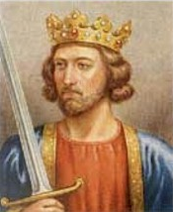
Contenders to the throne in 1066
Harold Godwinson (1022-1066)
Harold was earl of Wessex and claimed that Edward had promised him the throne and his deathbed. He was also Edward’s brother-in-law. He had been loyal to Edward and had a lot of influence with the other Earls of England.
Harold was announced as King by the Witan and crowned as Harold II.

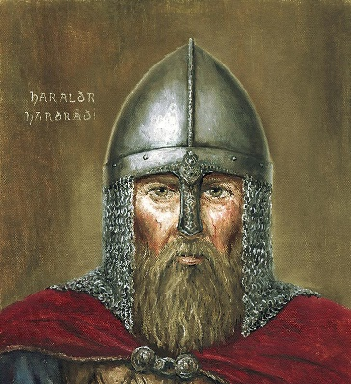
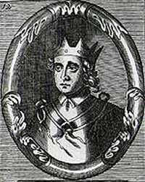
Harald Hardrada (1015-1066)
Hardrada was the king of Norway. He was a fearsome warrior and his name ‘Hardrada’ meant stern warrior. His claim to the throne was based on Viking secret deals and treaties.
Worked with Tostig Godwinson to invade England in 1066.
Edgar Aethling (1051-1126)
Edgar was Edward’s nephew and so was directly descended from royal blood. This is shown by his title ‘Aethling’ which meant a prince of royal blood.
However, Edgar was only a teenager when Edward died and it was believed that he did not have the military experience to deal with the threats from Scandanavia and Normandy, so they instead decided on Godwinson.

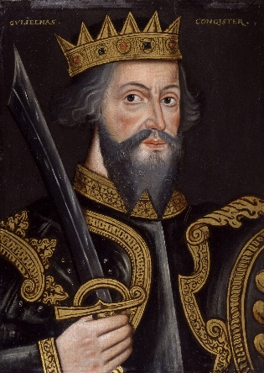
William Duke of Normandy (1028-1087)
William was Duke of Normandy, a small country surrounded by enemies. He had fought hard to survive since he was young and England offered the chance for wealth and success.
His claim was based on an agreement between himself and Edward the Confessor in around 1051 whereby Edward promised him the throne. This was supposedly confirmed by Harold Godwinson when he went to see William in 1064.

Timeline: 1042-1066
25th December 1066: William is crowned King of England.
14th October 1066: The Battle of Hastings
6th October 1066: Harold reaches London. He leaves London on 12th.
27th September 1066: William’s fleet set sail for England and land the next day.
25th September 1066: The Battle of Stamford Bridge.
January 1066: Edward the Confessor dies and promises Harold the throne on his deathbed. Harold becomes king.
20th September 1066: The Battle of Gate Fulford.
1065: Uprising against Tostig. Harold supports the rebels and Tostig is exiled.
1064: Harold’s embassy to Normandy ends with him swearing an oath that William will be the next King of England.
1055: Tostig, Harold’s brother, becomes Earl of Northumbria.
1053: Earl Godwin dies and is replaced by Harold Godwinson.
1051: Edward visits William in Normandy and it is here where h supposedly promises him the crown.
1042: Edward the Confessor become king.
1050: Tension escalated between Godwin and Edward over Godwin’s refusal to punish the people of Dover for their treatment of a visitor from Boulogne

Key topic 2: William I in power: securing the kingdom, 1066-87
Key area | Content | Revised
Establishing control | - The submission of the earls, 1066  - Rewarding followers and establishing control of the borderlands through the use of earls. The Marcher earldoms.  - Reasons for the building of castles; their key features and importance.
The causes and outcomes of Anglo-Saxon resistance 1068-71 | - The revolt of Earls Edwin and Morcar in 1068  - Edgar the Aethling and the rebellions in the North, 1069  - Hereward the Wake and rebellion at Ely, 1070-71
The legacy of resistance to 1087 | - The reasons for and features of the Harrying of the North, 1069-70. Its immediate and long term impact, 1069-87.  - Changes in land ownership from Anglo- Saxon to Norman, 1066-87  - How William I maintained royal power.
Revolt of the Earls, 1075 | - Reasons for and features of the revolt  - The defeat of the revolt and its effects.

So, what happened after the Battle of Hastings?
Although William had won the battle, the Anglo-Saxon nobles did not come and surrender to him. Instead they went to London and the Witan elected Edgar Aethling to be king. He was supported by key aristocrats such as Earls Edwin (Earl of Mercia) and Morcar (Earl of Northumbria). It seemed like William would have to come to them.
William secured the south coast to ensure that he had a supply line from Normandy. He also got ill and could have easily been defeated had the nobles travelled south of London. Once he had secured the south, William led his troops on a march to London. As they went they destroyed homes and farms.
William did not attack London directly as it was heavily fortified, instead he travelled to Birkhamstead to the North West of London. He was met there by Edgar Aethling, Archbishop Ealdred and both Edwin and Morcar. They submitted to William and swore oaths to obey him and gave him hostages to guarantee their promises. They offered him the crown and in return William promised to be ‘gracious’ to them. On 25th December 1066 William was crowned king.
Key differences between Anglo-Saxon and Norman rule
Anglo Saxon | Norman
The King did not own all the land in England. He owned a lot and could give it and take it away, but land was usually inherited through generations of families. | William claimed that as King he was in charge of all the land in England and the only way people could get land was through his saying so. He would give land to those who he felt were loyal and could take it away if they did anything wrong.
Earldom’s were large and had a lot of power e.g. Earl Godwin. | Earldoms made smaller and the power of earls was reduced.
Anglo-Saxon’s did not have marcher earldoms, in theory each earl had the same responsibilities and none were exempt from tax. | Created Marcher earldoms on the border between England and Wales. There were three Marcher earldoms- Chester, Shrewsbury and Hereford and gave these to people who had helped him win the battle. These had special privileges and were exempt from paying tax on lands. They could also build castles.
Instead of castles, large Anglo-Saxon towns or burhs were protected by walls that encompassed the whole town, rather than just a castle and the knights. | William gained control of trouble spots through the use of castles. He ordered that these be built in strategic locations and formed the base from which to launch attacks or give knights refuge in the event of an attack. They did not however, protect the whole town.
Anglo-Saxon earls named who they wanted to inherit their land and this was agreed. Smaller farmers leased land for as long as three generations. | Initially, William kept many Anglo-Saxons in their position as earl. For example, Morcar kept his position. This changed however with all the rebellions and more and more titles went to Normans rather than Anglo-Saxons. He also made people pay William for the right to keep farming their land. This led to resentment.
Before this a tax had to be paid to the Lord and not to the king. | William introduced a tax when an earl died. This had to be paid to the King before the heir could become earl.

Keywords for securing William’s power
Word | Definition
Bailey | The outer part of the castle, surrounding the motte and protected by a fence or wall.
Castellan | The governor of a castle and its surrounding lands.
Colonisation | When one country encourages migration of its people to another country.
Excommunication | Cutting someone off from the church community so that they are unable to confess their sins before they die and wouldn’t go to heaven.
Forfeit | To lose something as a punishment for committing a crime or a bad action.
Genocide | A deliberate and organised attempt to exterminate an entire group of people.
Guerrilla war | When small bands attack a larger force by surprise and then disappear back into the local population. Modern term.
Harrying | An old word meaning to lay waste to something, to devastate it.
Magnate | An important and influential figure
March | An Anglo-Saxon term for border
Motte | The mound of earth that a castle stood on.
Reconciliation | To find ways for enemies to forgive each other.
Submission | Formal acceptance of and surrender to authority.
Tenants-in-chief | Large landholders of Norman England who held land directly from the king.
Tenure | ‘To hold’ in Latin with regards to land.
Vassal | Someone who holds land in return for their services to their Norman lord.
Writ | Official document from the King signed and sealed with the Kings personal seal.

Key people in Norman England: 1066-87
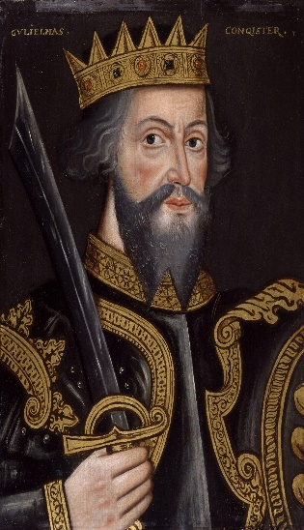
King William I
Reigned: 1066-87
William won the Battle of Hastings and became King of England on Christmas day 1066. During his reign he faced many rebellions from Anglo-Saxon earls who were angry and his new rule and the changes they faced, as well as from Vikings and his own earls.
William consolidated his power through using a number of tactics such as terror- destroying large areas of the North so they could not rebel, castle building and through administrative control of all land. He demanded loyalty and could be very ruthless to those who did not give him this.
William was very religious and believed that his victory at Hastings was God’s will.

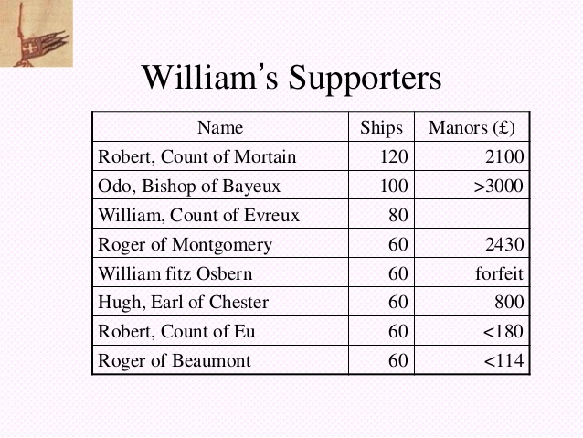
William’s loyal supporters:
Odo, Bishop of Bayuex: This was William’s half brother who had contributed 100 ships to the Battle of Hastings. He was rewarded by gaining control of Kent. He did not rule this area well.
William FitzOsbern: One of William’s most trusted advisers who was granted the Isle of Wight, much of Hampshire and large areas of the West.
Robert of Montgomery: Governed Normandy in William’s absence was rewarded land in Essex and Sussex, and made Earl of Shrewsbury.

Earl Morcar
Earl of Northumbria
Morcar was also Anglo-Saxon but had taken an oath of allegiance to Wiliam. Like Edwin, Morcar was annoyed at William. He had reduced the size of Morcar’s earldom. Loss of land meant a loss of money for Morcar, as well as a reduction in power. This angered him greatly.
In 1068, Morcar was involved in a rebellion against William’s rule, along with Earl Edwin and Edgar Aethling. However, once he was aware of William’s power he quickly surrendered.
He was allowed to keep his earldom, but like Edwin, became a ‘guest’ at William’s court.
Morcar tried to rebel again in 1070 and was caught. He was then imprisoned for life by William.
Earl Edwin
Earl of Mercia
Edwin was Anglo-Saxon but had taken an oath of allegiance to William.
Edwin became unhappy with William as William had promised Edwin could marry his daughter- however, this had not happened. He had also reduced the size of Edwin’s earldom. He also resented having to pay Geld Tax as he did not believe that this tax was being used for the good of England and was instead being used in Normandy.
In 1068 he was involved in a revolt against William. He fled from his court and started to build up support but soon surrendered when William demonstrated his power.
William pardoned him for his role in the uprising, but kept him as a ‘guest’ at his court where he could be kept an eye on
Killed in 1071 by his own men turning on him.

Edgar Atheling
Edgar was Edward’s nephew and had a legitimate claim to the English throne. In 1066 the Witan decided that the throne should go to Harold Godwinson, but on his defeat, they crowned Edgar. However, he soon pledged an oath of loyalty to William.
In 1068, Edgar had been involved in the rebellion with Morcar and Edwin, however had escaped to Scotland. He watched events closely and a series of revolts broke out in 1069 in the North of England. The Earl of northern Northumbria, Robert Cumin was murdered and a similar uprising occurred in York. Edgar Aethling and his supporters came down from Scotland and joined the rebels. William defeated th rebels and Edgar again escaped to Scotland. He then formed an alliance with King Seweyn of Denmark for an Anglo-Danish attack on York. They were victorious at York and an estimated 3,000 Normans were killed. William paid the Danes to end their invasion and embarked upon the Harrying of the North to stop rebellions in the North.
After the revolts, Edgar spent time in Scotland and Normandy but eventually, he was convinced to stop trying to take William’s throne and was allowed to return to England.

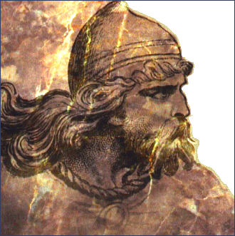
Hereward the Wake
He was an East Anglian local thegn who had been exiled by Edward the Confessor and had returned to England to find his lands had been seized by Normans. Hereward had been fighting a guerrilla war against the Norman Archbishop of Peterborough. He made alliances with the Danes and together they raided Peterborough abbey. The Danes stole the gains from the raids and sailed off, Hereward was joined on these raids by Morcar and they both tried to defend Ely from attacks. In the end they were defeated but both Morcar and Hereward escaped. Hereward was not heard of again.

Revolt of the Earls
Ralph de Gael- Earl of East Anglia
Roger de Breteuil- Earl of Hereford and son of William FitzOsbern
Waltheof- Earl of Northumberia, the only Anglo-Saxon rebel.
These three earls plotted together to overthrow William in 1075 and divide England into three. They had the support of the Danes for this plan. The rebellion was unsuccessful and Ralph and Waltheof fled. Eventually Waltheof was tricked into returning and was executed. Roger was imprisoned for life.

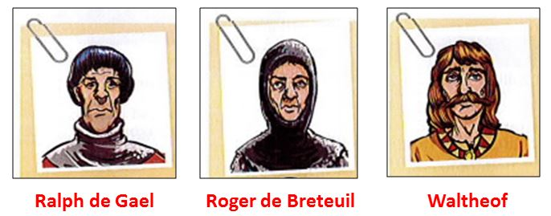

Timeline: 1066-88
25th December 1066: William is crowned King of England.
1076- Waltheof’s lands forfeited. Waltheof executed May 1076.
1075- Revolt of the Earls
1070-71- Morcar and Edwin’s land forfeited.
1070-71- Hereward the Wake and the rebellion at Ely.
1069-70- The Harrying of the North.
December 1069: William pays the Danes to leave and the threat is over.
September 1069- Combined Anglo-Danish force defeat Norman Army at York.
February 1069- Uprisings in York. Edgar joins uprising from Scotland.
31st January 1069- Earl Robert Cumin is killed in Durham. Leads to more rebellions
1068: The revolt of Edwin and Morcar

Key Topic 3: Norman England, 1066-88
Key area | Content | Revised
The feudal system and the Church | - The feudal hierarchy. The role and importance of tenants-in-chief and knights. The nature of feudalism (landholding, homage, knight, service, labour service); forfeiture.  - The Church of England: its role in society and relationship to government, including the roles of Stigand and Lanfranc. The Normanisation and reform of the Church in the reign of William I.  - The extent of change to Anglo-Saxon society and the economy.
Norman government | - Changes to the government after the Conquest. Centralised power and the limited use of earls under William I. The role of regents.  - The office of sherriff and the demesne. Introduction and significance of the ‘Forest’.  - Domesday Book and its significance for Norman government and finance.
The Norman aristocracy | - The culture and language of the Norman aristocracy.  - The career and significance of Bishop Odo.
William I and his sons | - Character and personality of William I and his relations with Robert. Robert and the revolt in Normandy, 1077-80.  - William’s death and the disputed succession. William Rufus and the defeat of Robert and Odo.

Key words for Norman England
Barony | The lands held by a baron from the king.
Demense | The land that the king or a tenant kept for his own use rather than granting as a fief to an under-tenant. Different to the king’s forests.
Domesday Book | A book that recorded the land holdings for the whole of England to decide how much tax they should pay and who should fight.
Feudal system | The system by which Norman society ran. This depended on the granting of land for loyalty and military services, was another way for the king to control the population.
Fief | Land held by a vassal in return for service to the lord.
Forest | An area of land that has rules regarding hunting and fines which people have to pay to the king for breaking these rules.
Forfeiture | If a land-user did not provide the service required of them, they could be made to give up their land or pay a fine. This was the punishment for breaking the relationship between the landholder and tenant.
Homage | To demonstrate allegiance to another person publicly.
Knight Service | The duty to provide a mounted knight to the king in exchange for a grant of land. The vassal had to ensure he had the right armour, weapons and equipment to carry out their service.
Labour service | Peasants would promise to work on their lord’s land and in return would be given a small patch of land to farm.
Regent | Someone appointed to act for a king or queen when they are underage, unable to rule because of illness or out of the country.

The Feudal System
Because William had won the Battle of Hastings and conquered England, he was able to claim that he owned all the land in England. He could then use this land to ensure loyalty. This was done through the Feudal system. This was made up of the following:
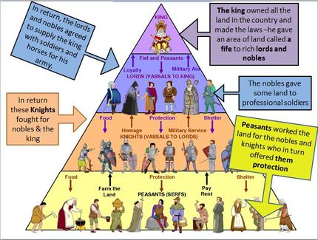
  - The King-He owned all the land and chose who to award land to based on their loyalty to him. Once he distributed land to Tenants-in-Chief they had to hold a ceremony of homage to William, whereby they swore to be loyal to him and fight for him in battle. They also agreed to provide knights in battle.
  - Tenants-in-Chief- These were similar to the position of earls and were made up of lords, bishops and barons. They gained land e.g. Kent and in return would have to promise loyalty to the King and provide him with knights.
  - Under tenants (vassals)- these were knights or small land owners- similar to thegns. They had to fight for their lord and in return they were given a small amount of land. They had to take part in mandatory knights service- which was 40 days a year fighting for the King, unpaid. Their tenant-in-chief would provide correct equipment and weaponry.
  - Peasants- they would receive a tiny amount of land and in return would have to farm parts of the lords land. They would also have to supply food to the lord. This was known as land service.
The introduction of the ‘forest’
Another way William had power of the population was through the introduction of forests. These were pieces of land that William could take away from landowners (perhaps powerful people who he sees as a threat) and turn them into forests. They were not necessarily covered in trees, but it meant that the land was reserved for hunting and was protected by law.
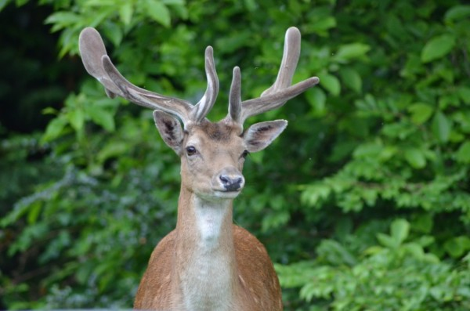
Forest laws were introduced to protect animals that were best to hunt- so that whilst hunting the King had something to catch. They also stopped damage to the vegetation to ensure that the animals had something to eat. Animals such as deer and wild boar were protected. It became an offense to carry a hunting weapon in these areas and hunt these animals and there were restrictions on cutting wood. This made life difficult for peasants as they lost a food source and were unable to get wood to burn to keep warm. Anybody caught breaking these rules would have to pay large fines.
William’s plans for centralisation
When William conquered England, one of his main aims was to ensure that everyone was loyal to him and that he had the most power. He did this by centralising his government. Before this, there had been large regional divides and the King had relatively little control over what happened in the different earldoms. William wanted to change this as he saw this as a threat to his authority. He centralised power in a number of ways:

- Fiefs and homage- William owned all the land and people had to pay homage to him to use this land. It could be taken away at any time- meaning William held the power.
- The Church- The King took control of all church land and had the right to appoint bishops. Lanfranc centralised power in the church, giving archbishops more control over regular bishops and parish priests.
- The Domesday Book- this was a document that stated what land was owned by who and what taxes they should pay. William could use this to his advantage.
- Royal demesne and forests- William directly controlled a lot more land than Edward ever had. This brought him income and helped reduce the power of others.

Structure of the church
Using the diagram below, can you think of how the church may have represented a threat to William?
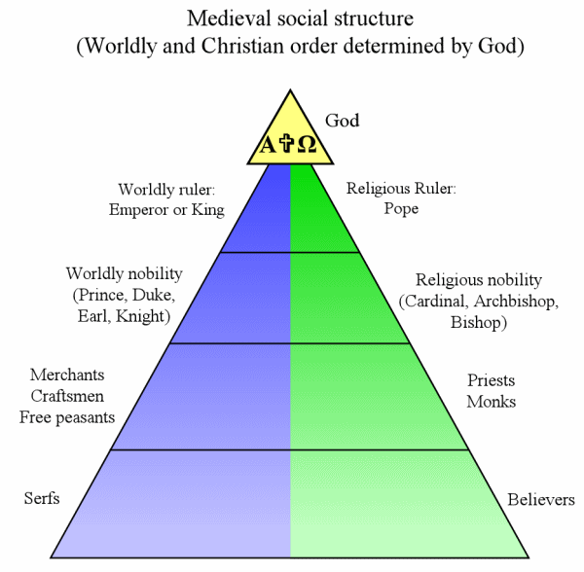
Peasants
Vassals and knights
Tenants- in-chief
Each village or town would have their own parish priest.
e.g. Archbishop of Canterbury. William made it so that all bishops were answerable to archbishops.

Key people
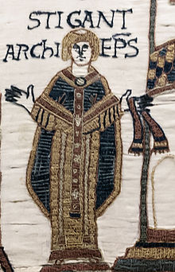
Archbishop Stigand
Was Archbishop of Canterbury from 1052-1070 and was Anglo-Saxon. He was a close ally of Earl Godwin, who insisted that Stigand be made Archbishop against Edward’s wishes. Whilst he was Archbishop, Stigand had little control over other bishops outside his area. Different parts of the country did different things. This changed under Lanfranc and William’s centralisation. Stigand was also a ‘pluralist’, he was a bishop in two different areas: Canterbury and Winchester. The reason he did this was that it allowed him more money. He was also accused of simony- te practice of taking money in exchange for church jobs. Stigand fell out of favour with William and was put into prison.

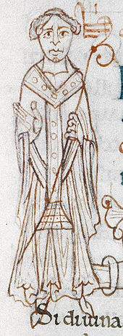
Archbishop Lanfranc
Lanfranc was an Italian monk who had run William’s monastery of St. Stephens in Normandy. He believed that the church and government should be totally separate and that priests should not be allowed to get married. He wanted the church to have a strict hierarchy: individual parish priests under the control of their bishops, with one archbishop to be the leader of all the priests in one country and they should be under the control of the Pope in Rome. Lanfranc passed a number of church reforms whilst Archbishop of Canterbury. These included setting up church courts to put bishops on trial which were separate from normal courts and the rebuilding of cathedrals in strategically important places.

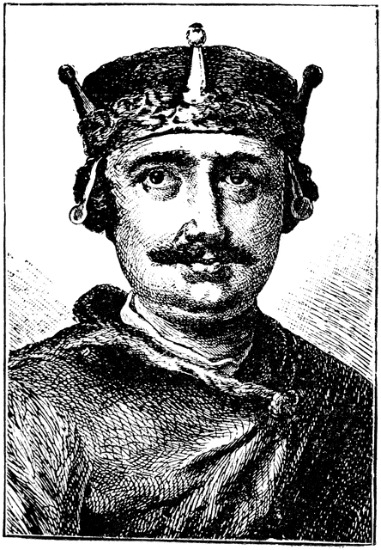
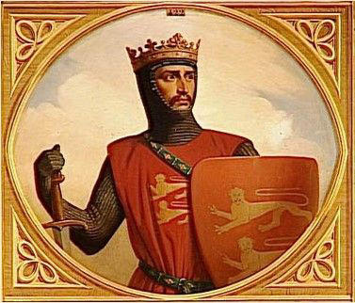
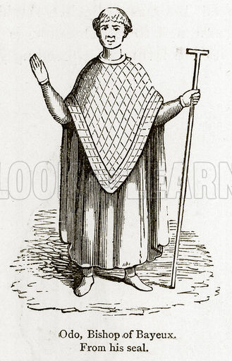
William Rufus
William Rufus was William’s favourite son. After his father’s death, William took a letter from his father to Lanfranc claiming that he should be made King. Lanfranc supported William’s claim and he was crowned King in September 1087.
Robert Curthose and Bishop Odo joined together in rebellion to William in 1088. This was unsuccessful and Robert was not able to become King.
Robert Curthose
Robert was William’s oldest son. William and Robert had a difficult relationship and Robert led a rebellion against his father and they fought each other in 1079. Despite this, they reconciled in 1080.
On William’s death, as the eldest son, Robert was set to inherit Normandy, however, William wanted his favourite son- William Rufus to have England. However, he left it up to them to decide who would rule England.
Bishop Odo
Odo was William’s half brother and in 1049 was made Bishop of Bayeux, even though his reputation was very poor. He was a major supporter of William’s invasion and as a result of this was rewarded with lots of land. He became the second largest landowner in England after the King.
In 1067 he was made co-regent with William FitzOsbern whilst William was away. During this time Odo destroyed many areas and seized land illegally. His actions turned many people against the Normans. He was made to give up the land he had stolen.
In 1079 he was sent to Northumbria following an attack from Scotland and laid waste to the region, robbing peopled and pillaging cathedral treasures. In 1082, Odo fell out of favour with William and was arrested.

