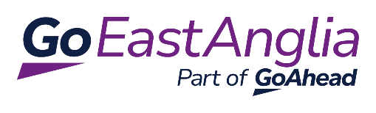

24th February 2025
Dear TGS
Company Rebrand Announcement
The year 2025 marks a significant period of transformation for our business as we work on embedding our core values into the heart of our operations. Our focus is on caring for our people, our passengers, our community, our assets, and our environment.
Starting from March 2025, we will implement substantial changes to our Konectbus network in Norfolk and from June 2025 in Essex and then Suffolk to better support our passengers and colleagues.
As part of our transformation, we plan to unify our three local brands under the existing name Konectbus to create consistency across the business. This will mean that our business will operate under one regional identity, fostering a sense of unity and pride among our colleagues as part of a single company.
The Hedingham and Chambers brand in the south will be phased out and all operations will be simplified under Konectbus. Our local brand names will be updated to Konectbus Norfolk and Konectbuses Essex and Suffolk. This distinction on our name is necessary to avoid confusion which may be caused by overlapping route numbers within our East Anglian network, especially when viewed on our website or app.
What does this mean for your students and your school?
Over the next few months, some of our buses which are used on school contracts in Norfolk will be repainted blue and feature a modernised logo and name.
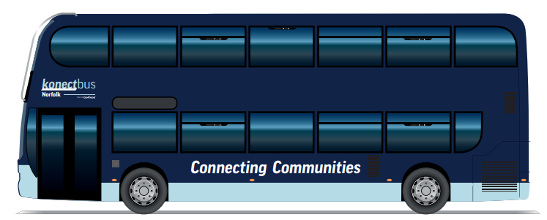
This rebrand will have the greatest impact on our contracted services across Suffolk and Essex where our Hedingham and Chambers brand will transition from being Red and Burgundy painted buses to become Dark Blue and the name will be changed to Konectbuses as show below.
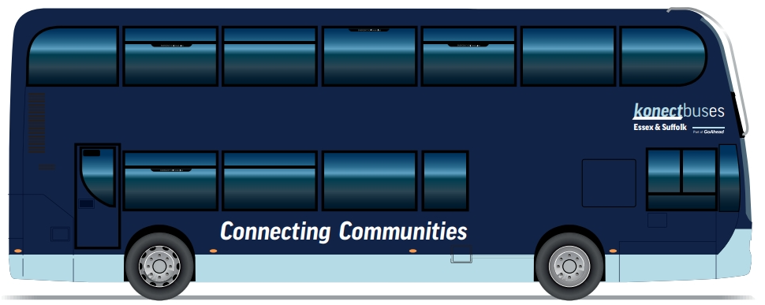
Please share this information with your students and their parents or carers to help them identify the correct buses for travel between home and school.
There will be a period when a mix of branded buses will be on the roads across our network, but we have created a comprehensive communication campaign to keep our passengers informed about the changes happening across our business. Part of the transition will include the introduction of newer and refurbished buses.
Our website, app and social media channels will remain as Konectbus in Norfolk but our Hedingham and Chambers sites will become Konectbuses www.konectbuses.co.uk and @konectbuses handles on our social media platforms. The Konectbuses app will be updated to display the newly branded fleet, allowing students to identify the bus they will be travelling on.
Bus Passes
From September, Suffolk County Council issued travel passes will continue to be provided to entitled students and those students in Essex who currently receive funding by the council for their bus travel will no longer receive a Hedingham and Chambers plastic card pass.
During the Summer term, we will work with you to transition, where possible, your students over to have digital passes on the Konectbuses app so that they can carry their bus pass on their mobile phone.
This will help to reduce the number of lost passes we recieve, speed up boarding at bus stops and aid punctuality of our services. We will also be able to share with your students how to set up service notifications onto their phones so that should there be any last minute changes to the route they travel on a particular day, they will be notified straight away.
We understand that in some circumstances a printed student pass or card will still be necessary for some students, and these will be issued on request.
For those fare-paying students, we will be encouraging parents to switch to our 30-day subscription ticketing which will allow us to remove our existing termly passes from sale.
This will help parents with their family budgeting as they can spread out the cost of their children’s bus travel as monthly payments and will also entitle students to enjoy discounted bus travel at the weekends when they show their pass to our drivers as they board the bus.
I hope you will all join me in supporting these changes as we transition through the consolidation of our three local brands under the single name of Konectbus and should you have any further questions or concerns, please do contact your schools liaison officer Sharon Walsh email GEAschools@goeastanglia.co.uk Sharon.walsh@goeastanglia.co.uk or 07890 903 007 / 01255 474849.

Kind regards,

Rupert Cox
Managing Director of Konectbus/ Go East Anglia

